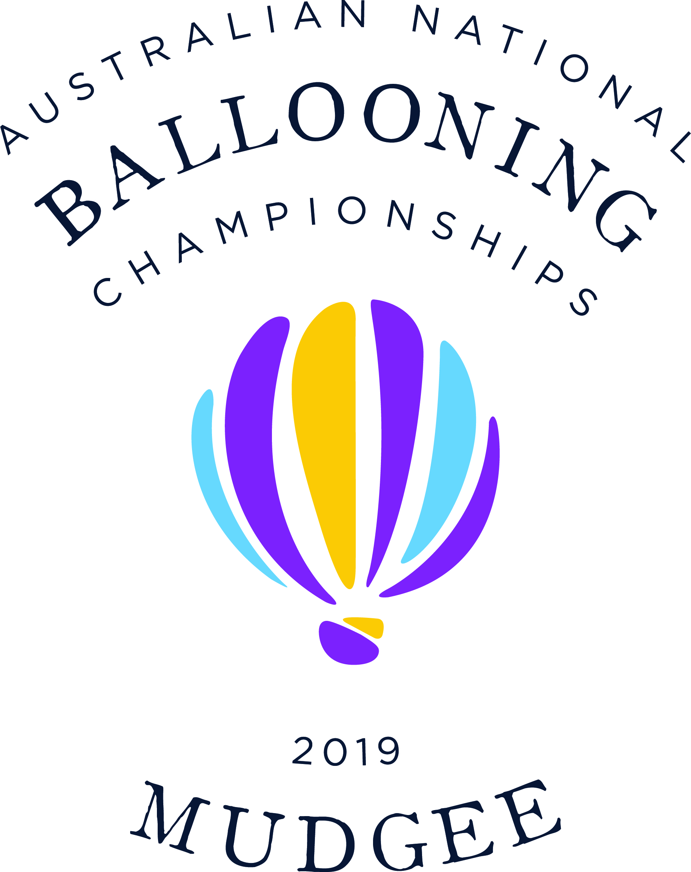

Pilot Registration Form

Pilot Information

Pilot Name

Postal Address

Mobile Number

ABF Number

PIC Hours

Paper Map | (please indicate number required: 0,1 or 2)
Balloon Information

Registration

Name

Volume

Logbook Hours

Insurance information

Policy Number

Insurance Company

Insurance Details *A minimum of AUD$2 million public liability is required
Expiry date

Crew Information

Crew Chief Name
Mobile Number

Entry Fee:  $400 To be paid via Bank transfer: | IBFC:  BSB: 032-516 - Account Number: 177145  *Please use pilots name as the reference.

The organisers will confirm within 10 days after having received your payment.

You will receive a confirmation of your registration. If you don’t get any confirmation, please contact the organisers via nationals@balloonaloft.com

- Your registration will only be considered if you have received a confirmation from the organisers and when the payment of your entry fee has been received.

By entering the event, I declare that I will have the following documents available for any required or requested check by the organisers or authorities:

- Current ABF Membership card,
- ABF PP(B)C (Not Temporary)
- ABF ROC or CASA FROL + Medical,
- Aerodrome Endorsement,
- Current FAI Sporting Licence,
- Pilot Logbook (with evidence of recent private BFR or commercial check flight),
- Balloon Logbook (with evidence of last annual/100 hourly) and no outstanding issues noted,
- Balloon CofR,
- Balloon CofA,
- Proof of balloon insurance cover for $2m public liability (you will be notified if any future add-ons are required for your insurance).

